Agile Development Group Project

Design Document

|  |  |
| --- | --- |
| Author: | Ada Bilska [adb34] |
| Config Ref: | CSM2020_WILSON_DBD |
| Date: | 24th March 2022 |
| Version: | 0.1 |
| Status: | Release |

Department of Computer Science

Aberystwyth University

Aberystwyth

Ceredigion

SY23 3DB

Copyright © Aberystwyth University 2022

CONTENTS

CONTENTS 2

1. Introduction 3

1.1 Purpose of this Document 3

1.2 Scope 3

2. BODY OF DOCUMENT 3

2.1 HOMEPAGE 3

2.2 About Page 3

2.3 Login Page 5

2.4 Register Page 5

REFERENCES 7

DOCUMENT HISTORY 8

# Introduction

## Purpose of this Document

This document describes all of the interface, design of the pages which we used to create this project. Each page will be describe carefully writing what user is able to see on the page, the URL diagram of the page, pseudocode, user story and Acceptance Criteria for each of the pages.

## Scope

Everything which is persistently stored for the project will be included within the document.

# BODY OF DOCUMENT

Each page will be presented separately, taking into account two potential users - a person who has an account on the site and a person who does not.

## Typical Users

On the website we have two types of typical users:

* Users without accounts
* Users with account

The main assumption of the website is to promote among students that cooking does not have to be expensive, time-consuming and demanding. The website aims to create a database of cheap recipes, which will be divided into 6 categories - picnic, party, dinner, dessert, drink and more - so that users can easily find something special for themselves. Users without an account will be able to search for any recipes or by a specific category. After finding a recipe for himself for dinner, at a party, the user is able to see the recipe details with all nutritional values, suggested price and how long it may take.

When the user wants to become one of the authors of the recipes and become a larger part of the community in the group, he can create an account that will give the user many more functions, such as adding their own recipes, editing their recipes.

## Use cases

Use cases for users without account:

* Navigation menu on the top of the screen
* Register Page
* Login Page
* Main page:
* Display list of recipes
* Sort recipes by category
* Display list of recipes by author
* Display concrete recipe:
* Time of cooking
* Skills for cooking
* Ingredients
* Instruction
* Price
* For how many portions are this recipe

Use cases for users with account:

* Create account
* Change the password if user forgot the password
* Navigation menu on the top of the screen
* Login to the website
* Profile page:
  + Change password
  + Delete account
  + Update account details
* My recipe page:
  + Change your recipe
  + Delete your recipe
* New recipe page:
  + Add recipe
* HomePage:
  + Display list of recipes
  + Sort recipes by category
  + Display list of recipes by author
* Display concrete recipe:
  + Time of cooking
  + Skills for cooking
  + Ingredients
  + Instruction
  + Price
  + For how many portions are this recipe

## HOMEPAGE

## Recipe Detail Page

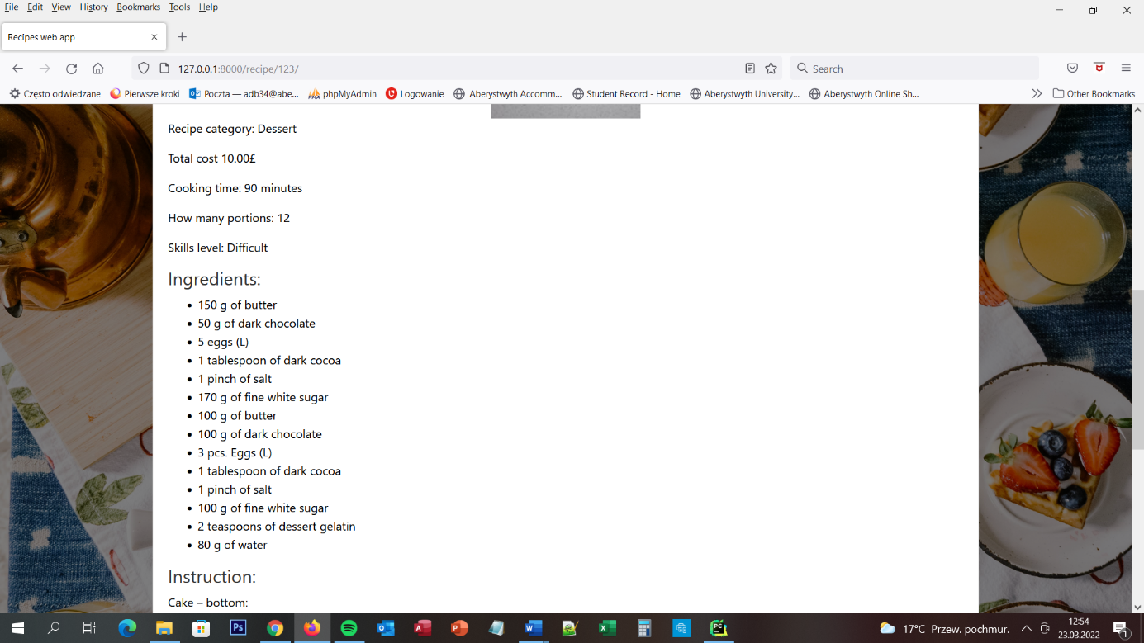

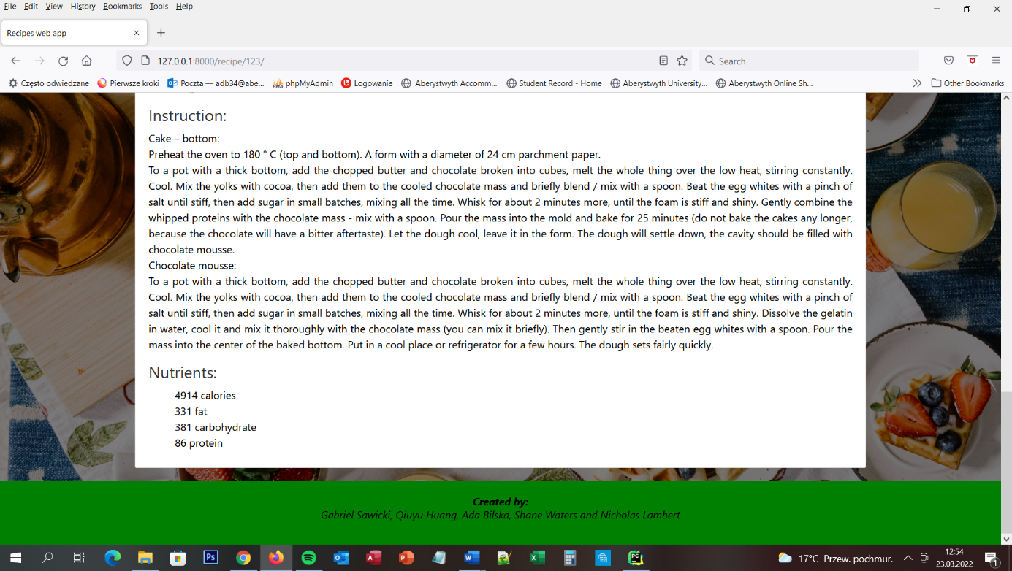

### Recipe Detail page

User doesn’t need to be login to the website to go to Recipe Detail page. On the screen user is able to see whole recipe detail for recipe which he/she chose on the HomePage or My recipe page. He/she is able to see very important warring - This recipe can contain allergens, please check it before cooking! – to make sure that user will check carefully whole ingredients before he/she will eat it. Then the user is able to see the name of the person which create this recipe and date when the recipe was created. If user is login to the website and he/she chose his/her recipe, user is able to see two buttons – UPDATE and DELETE – to update and to delete the recipe. Under this user is able to see – name of the recipe, photo, Ingredients, Instructions and Nutrients. On the top of the screen is located navigation bar menu with buttons to dedicated them pages and the logo of the website.

### URL diagram

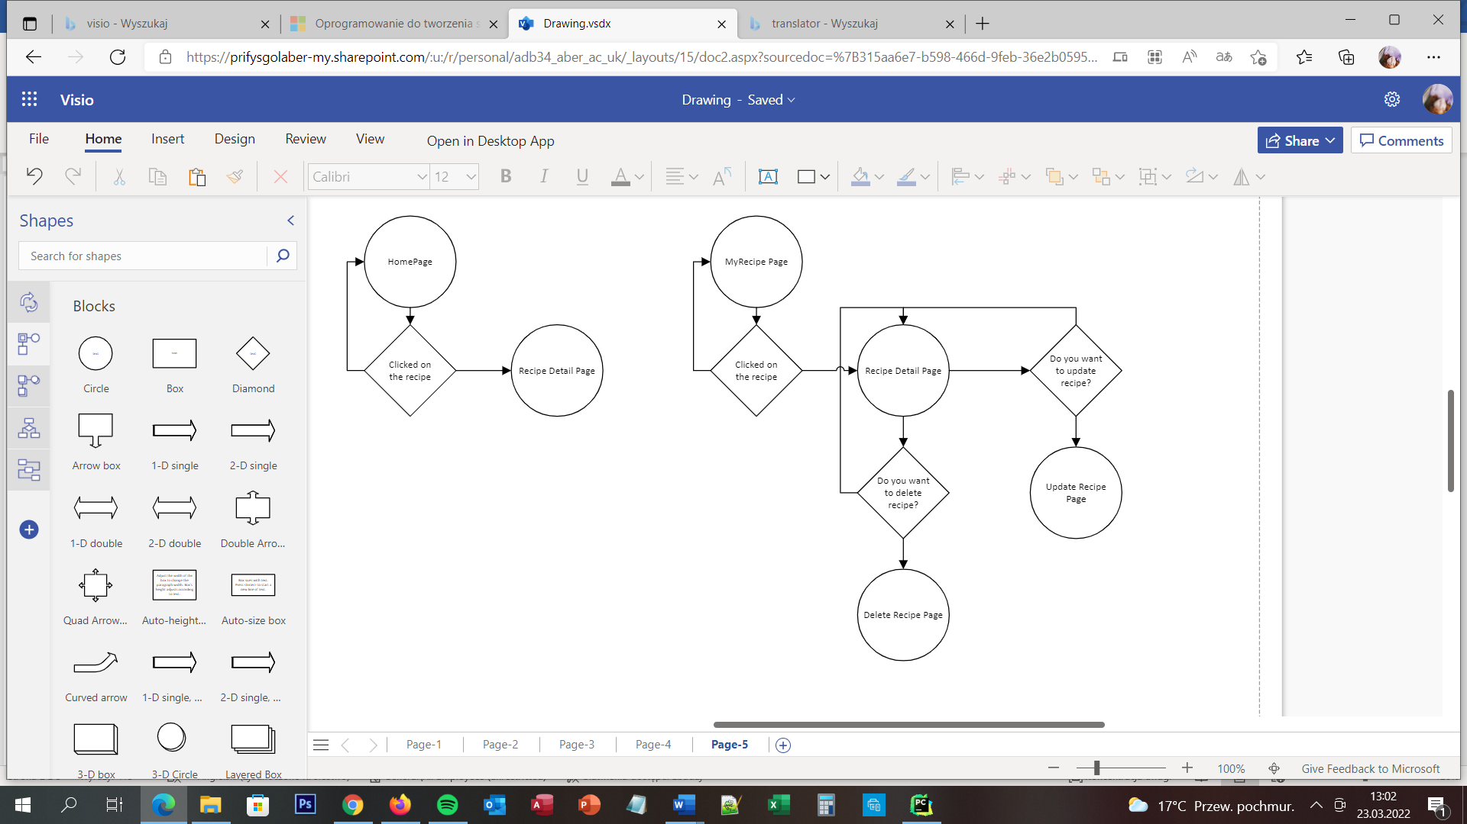

NO

NO

NO

NO

YES

YES

YES

YES

### User Story

User is able to view all of the details of all of the recipes. He/she is able to do that by going to the HomePage and clicks on the recipe or going to the My Recipe Page and did the same. User doesn’t need to be login to the website to see the recipe details. User wants to find recipe for himself/herself and he/she wants to see all details. User needs to go to the homepage, find the recipe and clicks on the recipe and then he/she will be move to Recipe Detail page.

### Acceptance Criteria

The page should display all of the recipe detail, name of the recipe, picture, ingredients, nutrients and instructions. If user is login to the website and he/she clicked on his/her recipe server should display two buttons – Update and Delete recipe. Eight buttons should move user to connecting pages:

* Homepage to Homepage
* About to About Page
* New recipes to Add recipe Page
* My recipes to My Recipes Page
* Profile to the Profile Page
* Logout to Logout Page
* Update to Update Recipe Page
* Delete to Delete Recipe Page

### User interface – Pseudo code

Detail Recipe Page is appear for all types of users. On the client side is chose the recipe. On the server side is display all of the recipe details from all of the tables, display buttons Update and Delete when user is login to the website and he/she chose his/her recipe.

## About Page

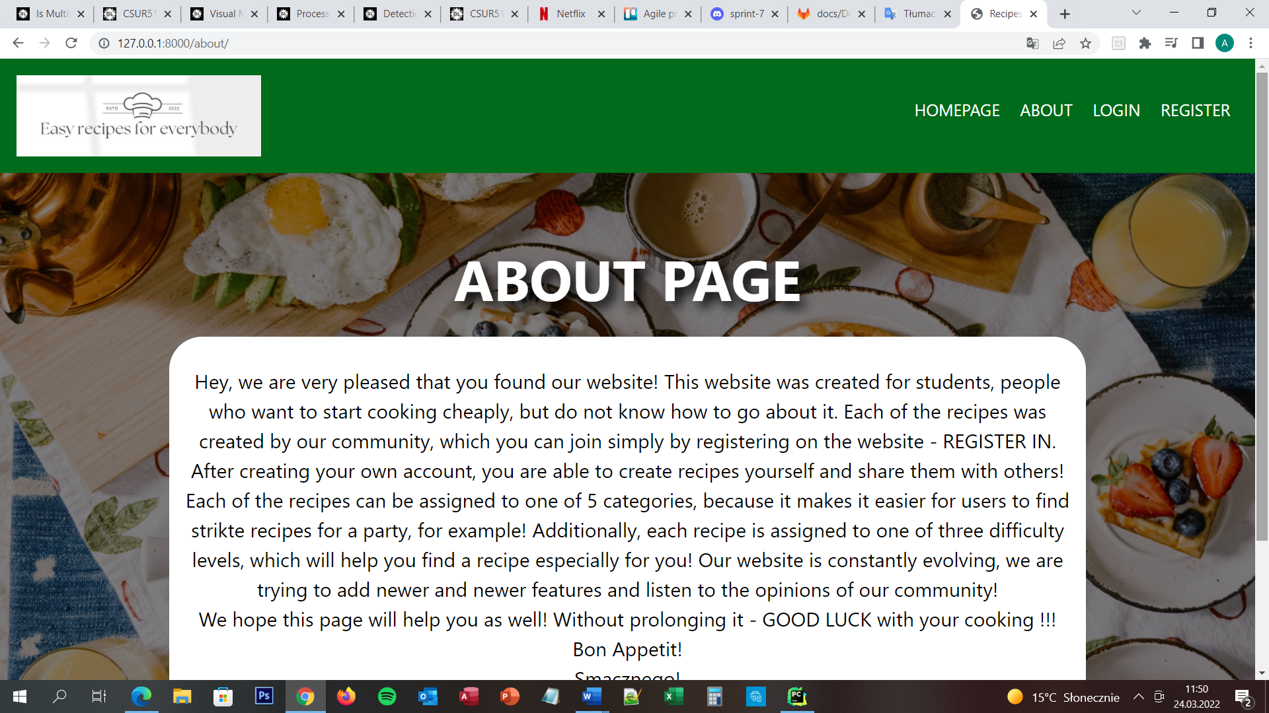

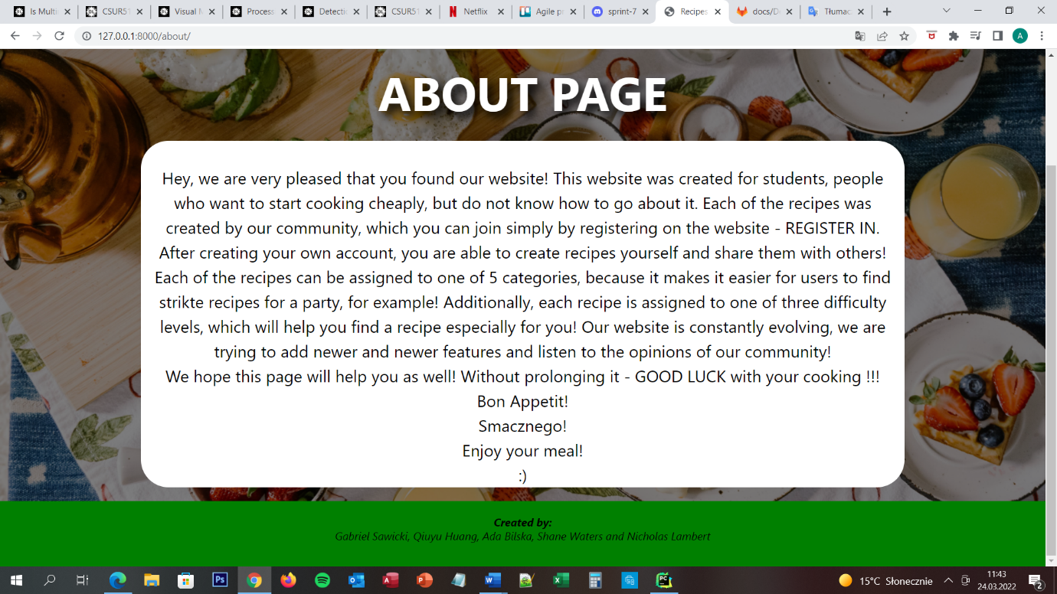

On the About Page user is able to see the message which describe to the user what exactly this page was created for, what is on it, how the user can use this page. At the top of the page is located navigation menu bar with four buttons – HOMEPAGE, ABOUT, LOGIN and REGISTER. All of this buttons are moving the user to the decidated them pages.

### URL Diagram

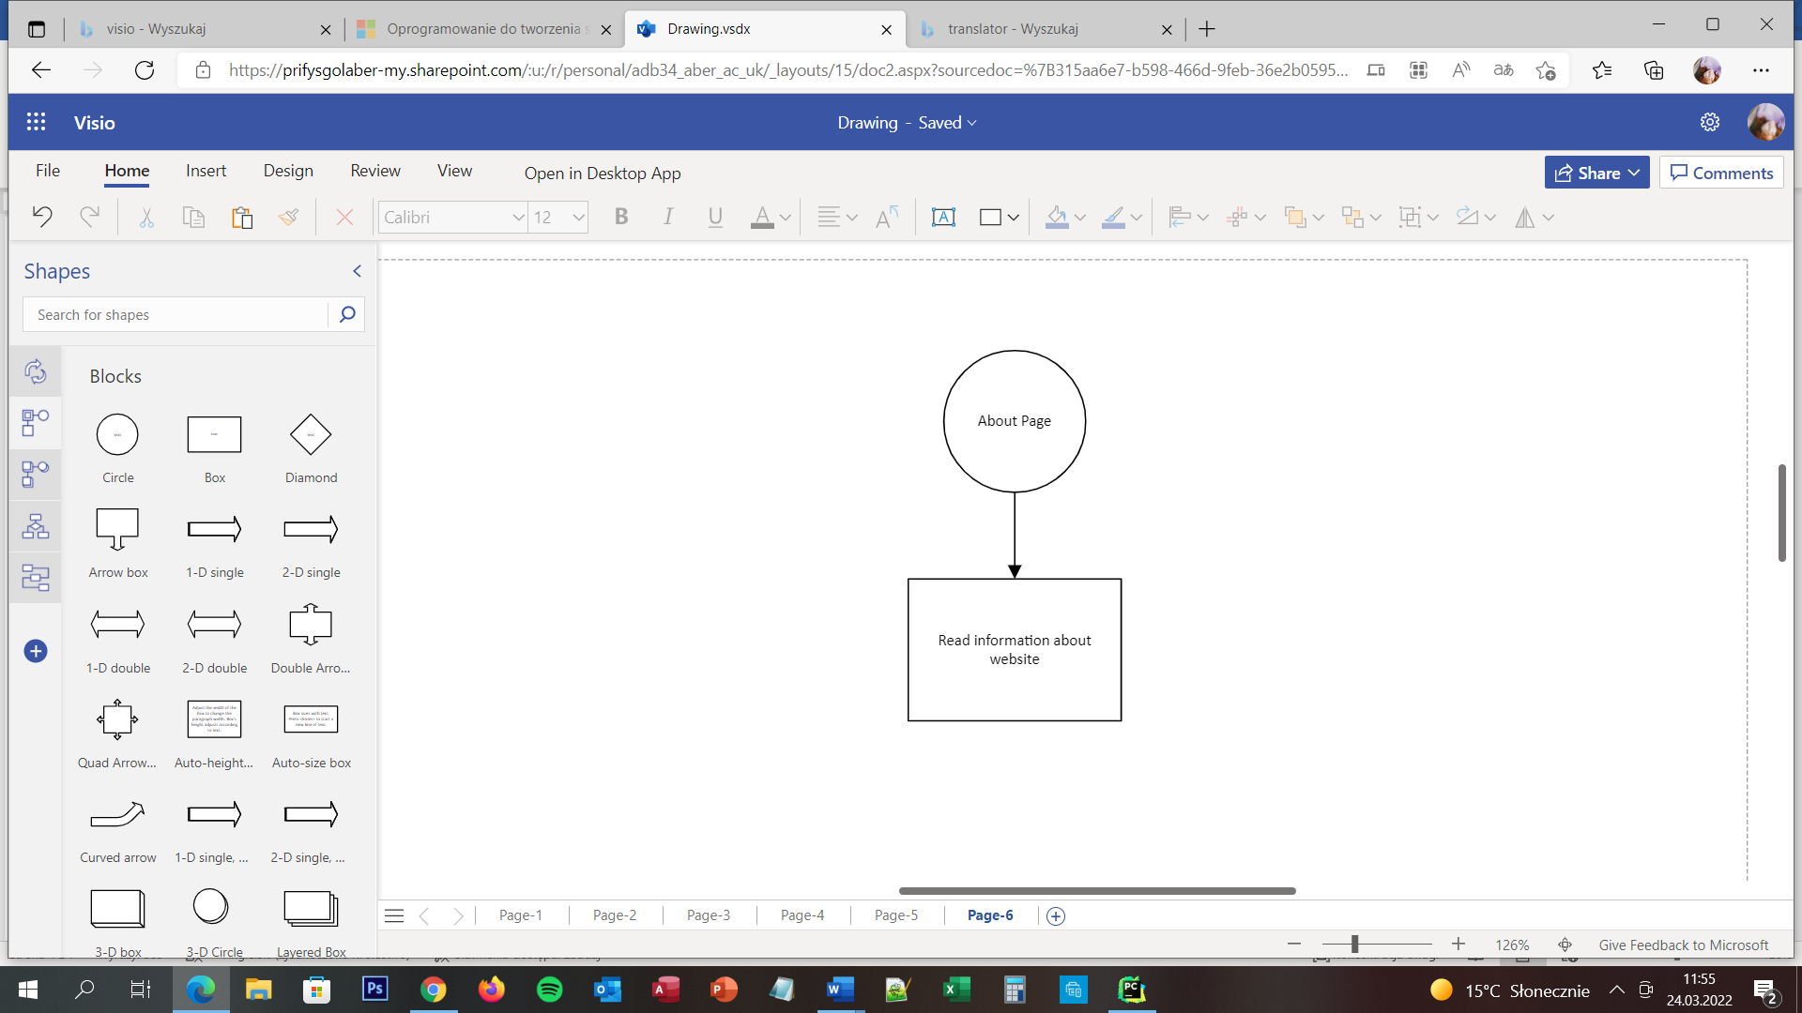

### User Story

When the user first finds the page, he does not know what it is for, what it was created for ect. To find out this information, just press the ABOUT button at the top of the screen and it will be taken to the ABOUT Page, which will find the answer to these questions.

### Acceptance Criteria

The page should display white box with all of the information about the website and navigation menu with four buttons. Buttons should move user to connecting pages:

* Homepage to Homepage
* About to About Page
* Login to Login Page
* Register to Register Page

### User interface – Pseudo code

On the client side is only click the button ABOUT to move to the about Page. On the server side is to move user to the About Page and display all of the information which should appear on the page.

## Login Page

## Register Page

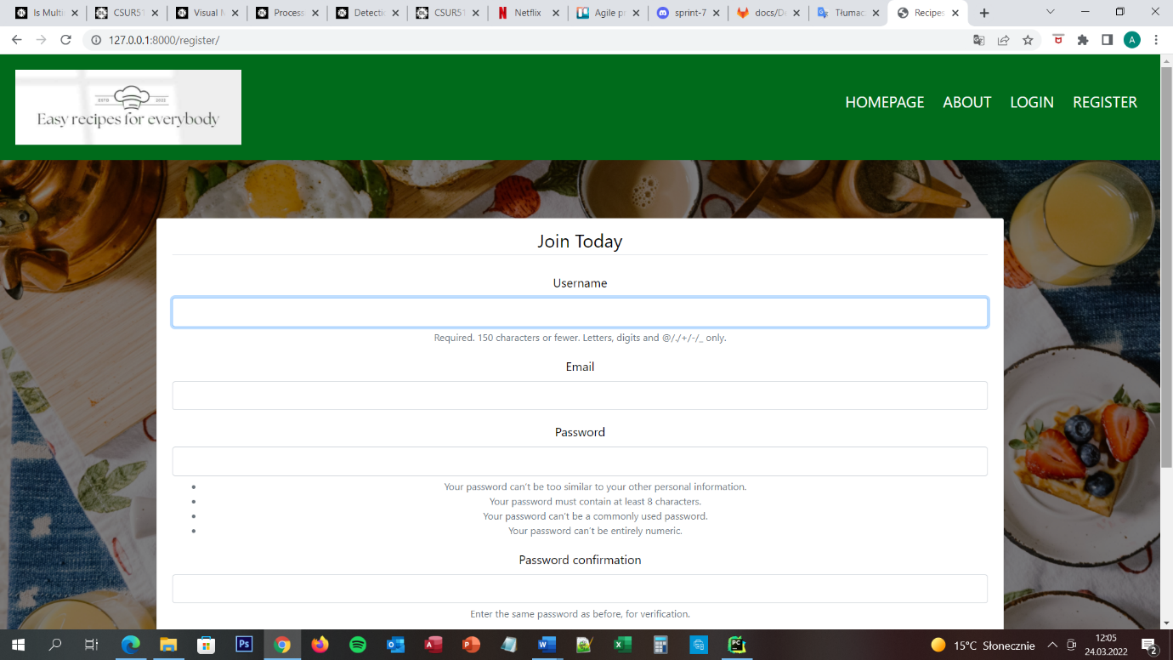

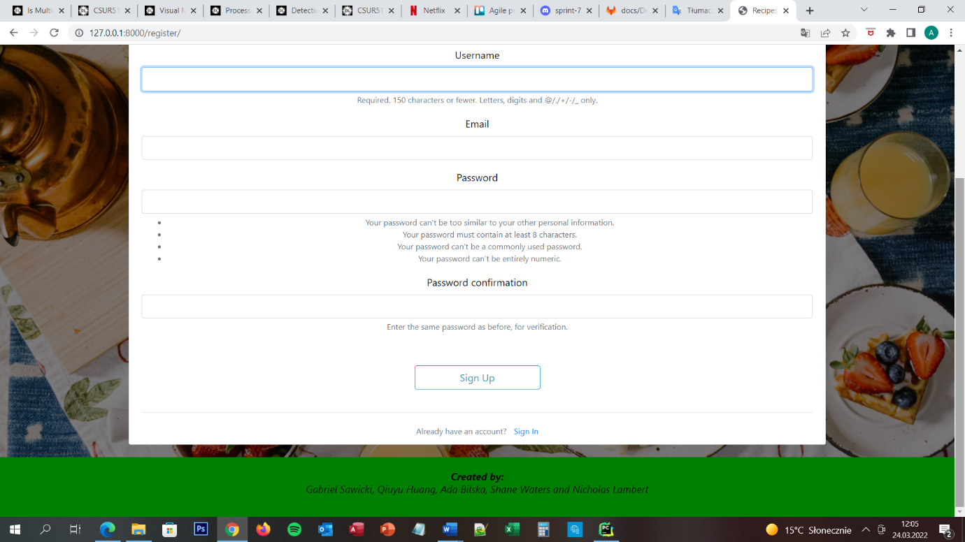

## Login Page

## New Recipe Page

## My Recipes Page

### My recipes page

When user is successfully login to the website he/she is able see My Recipes Page. On the screen the user can see all of recipes which he/she made. On the top of the screen user is able to see navigation menu bar with 6 buttons – HOMEPAGE, ABOUT, NEW RECIPES, MY RECIPES, PROFILE, LOGOUT – and the websites logo.

### URL diagram

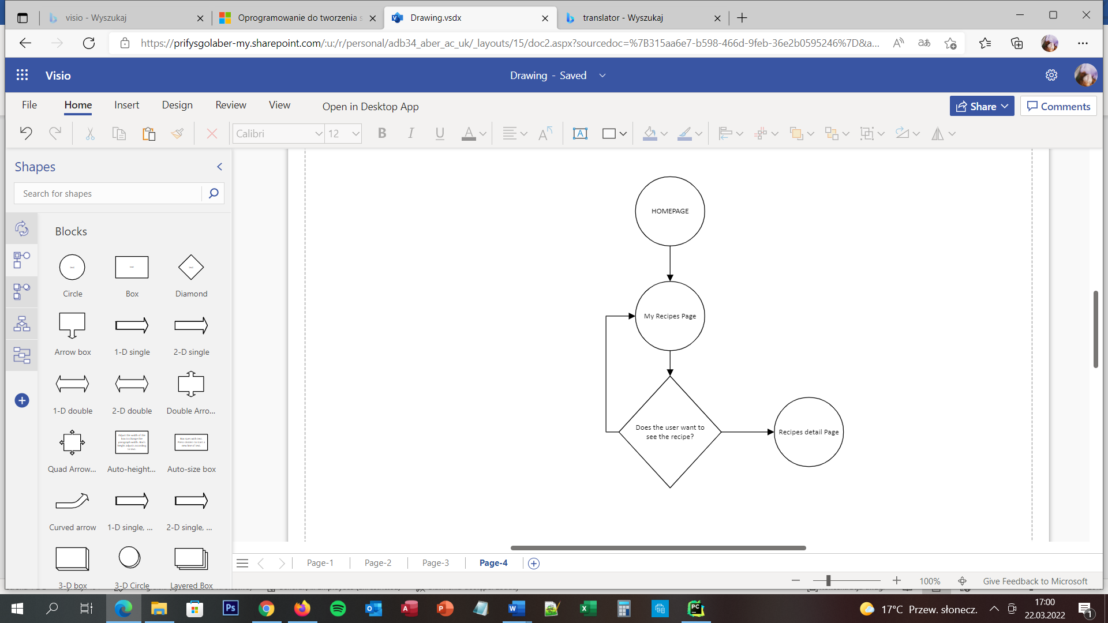

NO

YES

### User Story

User is able to view all of the recipes which he/she created by clicking the button – My Recipes – which is located on the top of the screen on navigation menu bar. On the screen is appear list of user recipes. If user wants to change them, delete them or view them user needs to clicked on the specific recipe and the he/she is moving to recipe detail page.

### Acceptance Criteria

The page should display list of recipes created by user and navigation menu bar. Each button should be clearly named. Seven of eight buttons should move user to connecting pages:

* Homepage to homepage
* About to about page
* New recipes to Add recipe page
* My recipes to my recipes page
* Profile should reload the page
* Logout to logout page

The tittle of each recipe should be a button which after user will clicked on this will be moving user to recipe detail page.

### User interface – Pseudo code

The My Recipes page is appear for the user when he/she is successfully log in to the website. On the client side is to press button My Recipes on the top screen navigation bar. On the server side is when user press this button – move him/her to My Recipes page. When the user will press any of the tittles to view details about the recipe – server needs to move user to the Recipes detail page.

## Delete Recipe Page

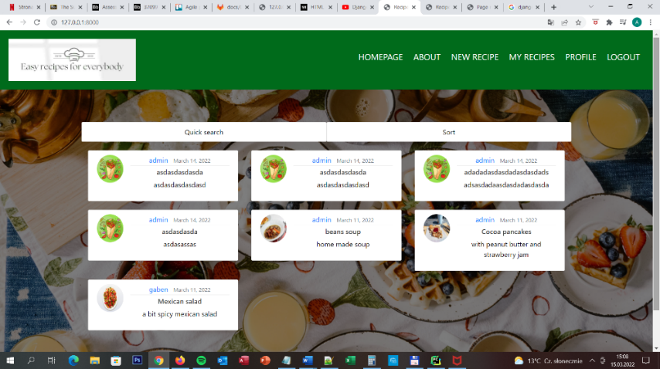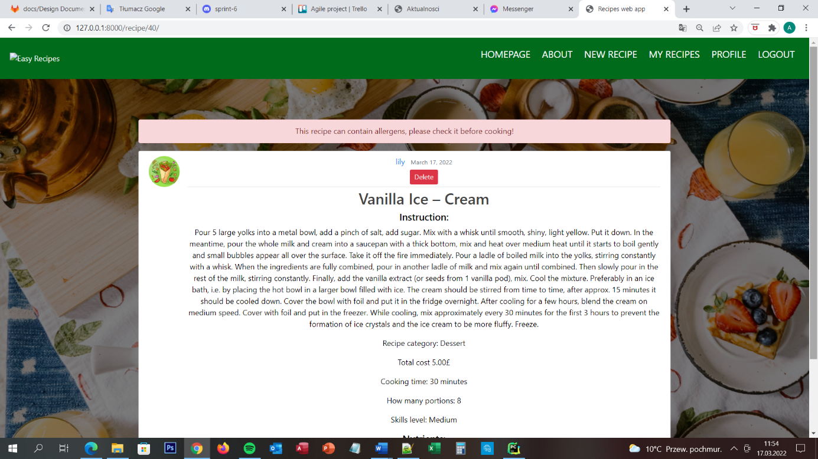

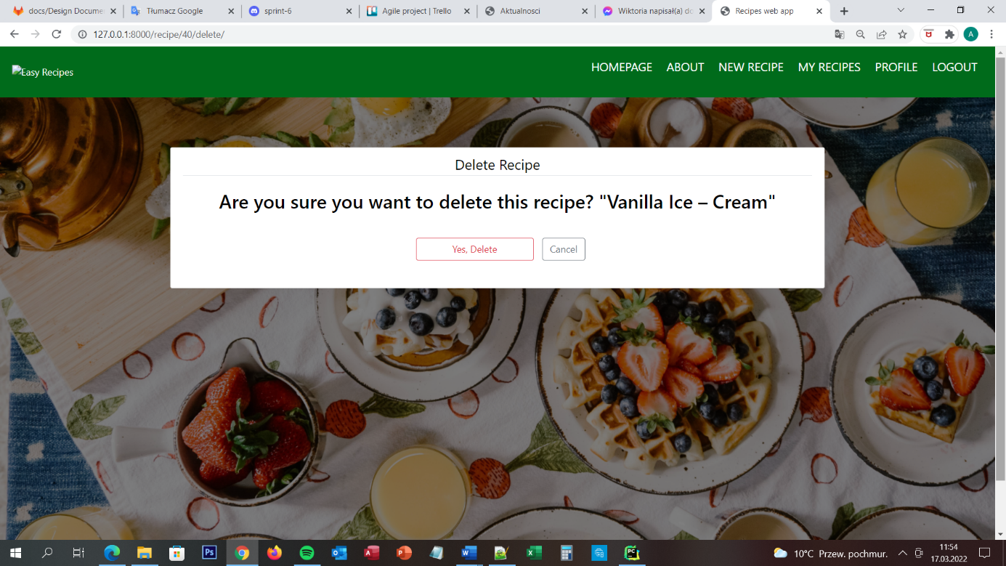

### Delete recipe page

When user is successfully login to the website he/she is able to add recipe, edit recipes and delete recipes. To delete recipe user needs to go to My Recipe page and click on the recipe which he/she wants to delete. Then on the screen is appear all details about recipe with red button DELETE on the top of the recipe. When user will click on this button he/she is moving to Delete Recipe Page. On the screen is appear message – Are You sure, you want to delete this recipe? – and two buttons – Yes, delete and Cancel. On the top of the screen is navigation menu with 6 buttons – Homepage, About, New Recipe, My Recipes, Profile and Logout. All of the buttons are moving user to the dedicated pages.

### URL diagram

NO

NO

NO

YES

YES

YES

### User Story

User is able to delete only the recipes which he/she created. He/she wants to do it, so user is going first to the My Recipe Page, choosing the recipe which he/she wants to delete, clicking on this recipe and then on the top of the recipe user is able to see red button DELETE. User is clicking the red button DELETE and he/she is moving to Delete Recipe Page. On the screen he/she see message is he/she sure that user wants to delete the recipe. Because user wants to delete it he/she is clicking Yes, Delete button. Recipe is delete. Nobody is no longer able to see this recipe.

### Acceptance Criteria

The page should display message, two buttons and navigation menu. Each button should be clearly named. Seven of eight buttons should move user to connecting pages:

* Homepage to Homepage
* About to About Page
* New recipes to New Recipe Page
* My recipes to My Recipes Page
* Profile to Profile Page
* Logout to Logout Page
* Cancel to Recipe Page

Yes, delete button should delete recipe from database and move user to the HomePage.

### User interface – Pseudo code

The Delete Recipe page is appear for the user when he/she is successfully log in to the website and when user chose his/her recipe which he/she wants to delete. On the client side is to choose the button Yes, delete or Cancel, to choose the button what next he wants to do with this recipe. On the server side is to delete recipe from database if user will press button Yes, delete or move user to the specific site which user chose on the navigation menu or by clicking button cancel.

## Update Recipe Page

### Profile page

When user successfully register in the website the server is creating profile for user. User needs to log in to the website and then he/she is able to click Profile button which is located on the navigation menu on the top of the screen. After he/she will press this button, user is move to the profile page. On this page user is able to see profile info like username and email address and he/she is able to update information about his/her account, change password or delete account. On the top of the screen he/she is able to see navigation menu with 6 buttons – HOMEPAGE, ABOUT, NEW RECIPES, MY RECIPES, PROFILE and LOGOUT. User is able to move to any of this pages by clicking the correct button on the navigation menu on the top of the screen.

### URL Diagram

YES

YES

NO

NO

### User Story

User is able to see this website only when he/she is successfully log in to the page – he/she already has account on the website. On the profile page user is able to change the password, delete an account, add new recipe, display his/her recipes, display favourite recipes. The Profile Page is a page on which are display a lot of buttons for all of this functions.

All of the button are display on the centre of the screen and all of the buttons are legibly and clearly described to make sure that website is intuitive and clear for user.

### Acceptance Criteria

The page should display five buttons, profile information and navigation bar. Each button should be clearly named. Eight of nine buttons should move user to connecting pages:

* Change password to Change Password Page
* Delete account to Delete Account Page
* Homepage to homepage
* About to about page
* New recipes to Add recipe page
* My recipes to my recipes page
* Profile should reload the page
* Logout to logout page

Submit button should submit the information about profile and reload whole page. User is able to change username and email address and after he/she presses button SUBMIIT the new data is sending to the database and uploaded the User table.

### User interface – Pseudo code

The profile page is appear for the user when he/she is successfully log in to the website. This is the first page which he/she can see after log in. If user will go to recipe Page he/she can easily come back to the page by using the button – Profile – on the navigation bar. On the client side is to choose what user want to do and press the button or change the email address or username by delete and type something new and then press button Update. Server side looks like this:

* Display buttons
* Move user to specific webpage after he/she presses the button
* When user will change the username or email address the server side needs to check if all of this information are correct with requirements and then change them in the database

## Update Profile Page

## Change Password Page

## Delete Account Page

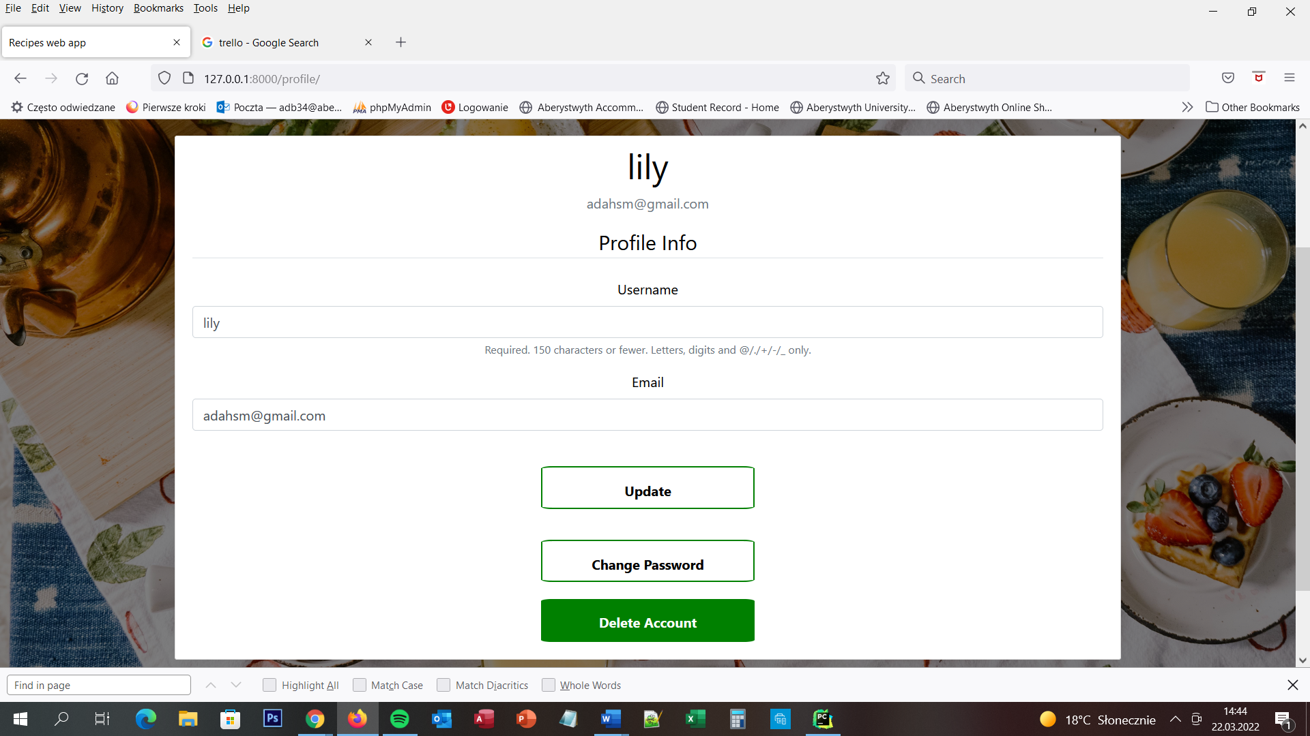

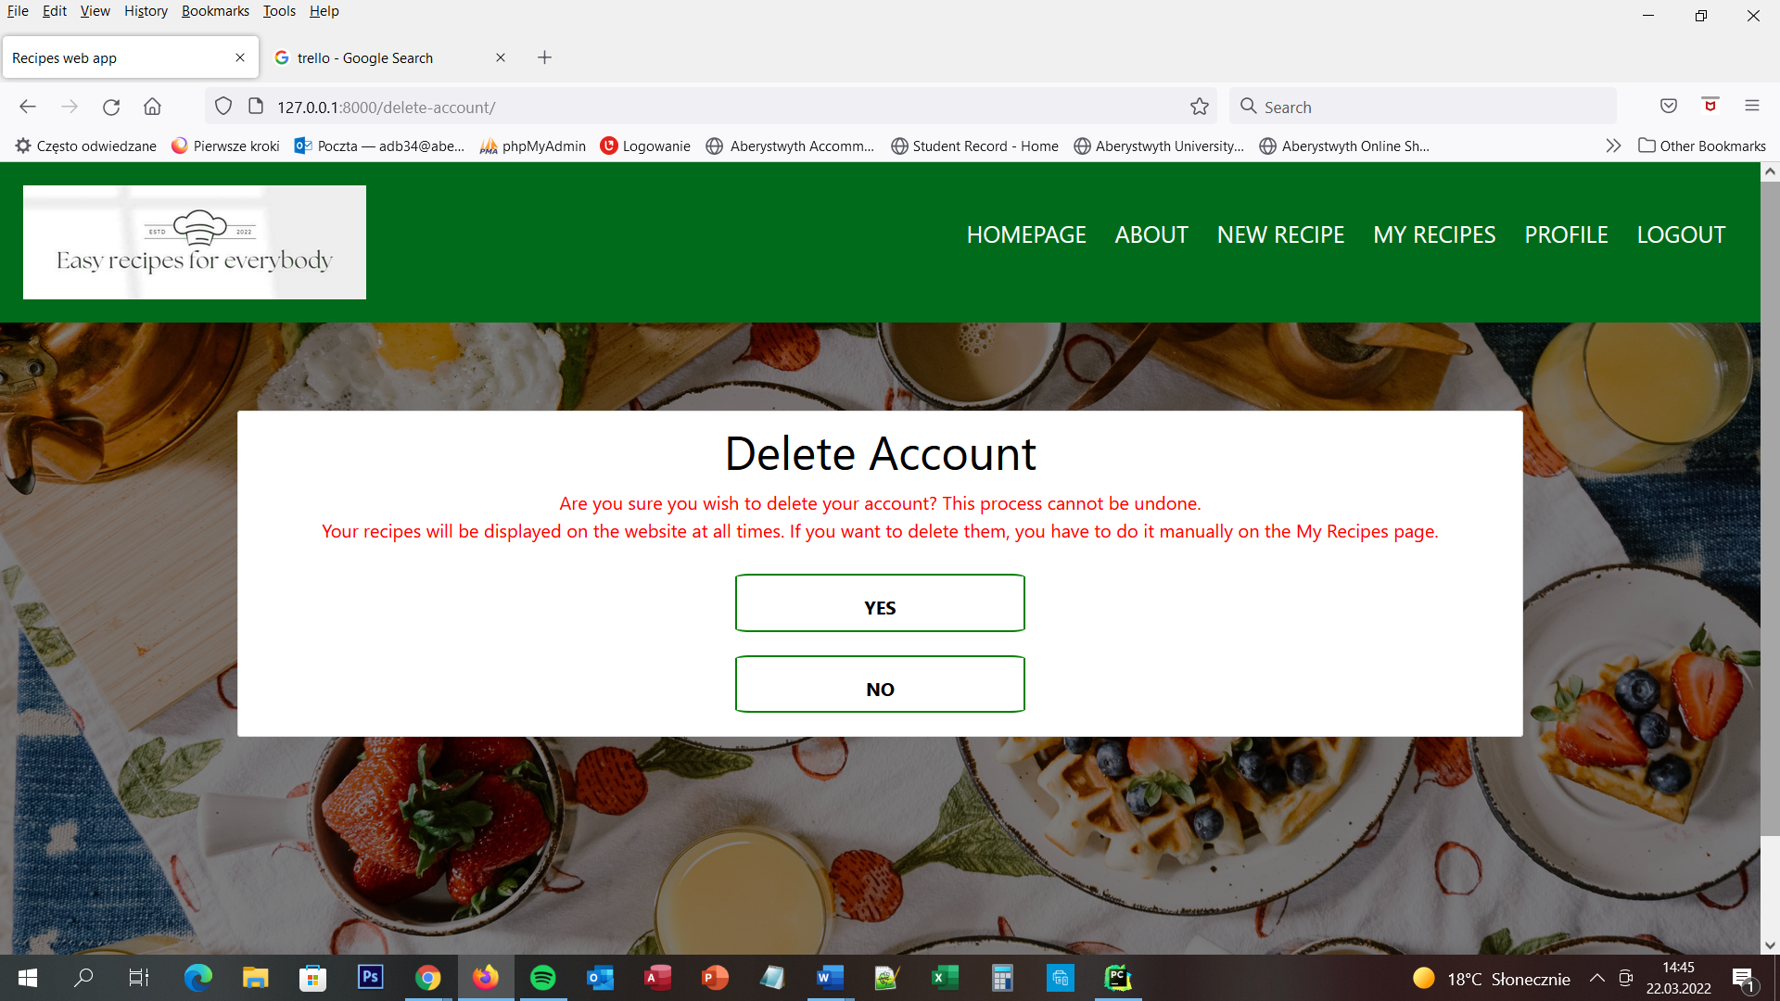

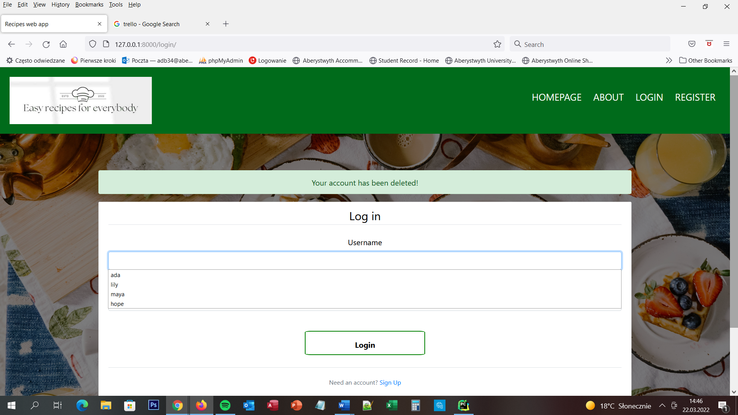

### Delete account page

When user is successfully login to the website he/she is able to delete his/her own account. User needs to go to Profile Page and then click button DELETE ACCOUNT. After this, he/she is moved to the Delete account Page. On the top of the screen user is able to see navigations menu bar with six button and website logo. All of the buttons are moving user to the dedicated pages. On the screen user is able to see message – Are you sure you wish to delete your account? This process cannot be undone. Your recipes will be displayed on the website at all times. If you want to delete them, you have to do it manually on the My Recipes page. – and two buttons – YES and NO. Button NO is moving ser to the Profile page again and button YES is deleting the user account and move user to Login Page.

### URL diagram

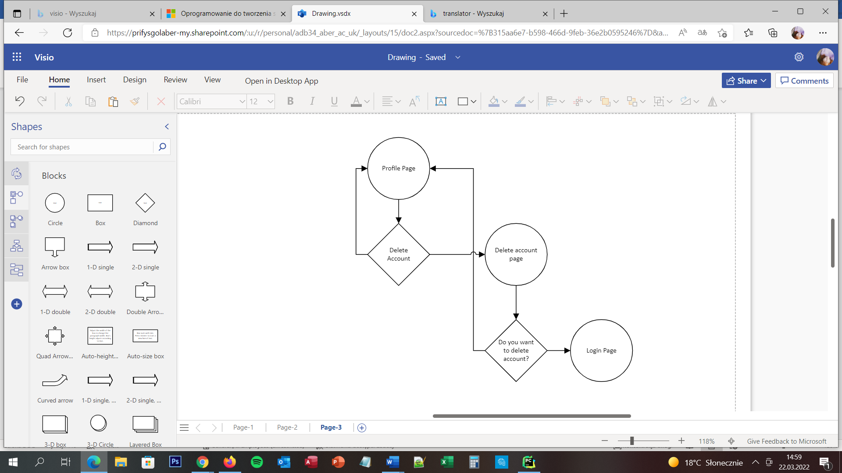

YES

YES

NO

NO

### User Story

User is able to delete account only when he/she is successfully login to the website ang he/she will go to Profile Page. When user do that he/she pressed button Delete Account and user is moving to Delete Account Page. Then he/she needs to answer the question - Are you sure you wish to delete your account? This process cannot be undone. Your recipes will be displayed on the website at all times. If you want to delete them, you have to do it manually on the My Recipes page . If user wants to delete all recipes too, he/she needs to press button NO and go to My Recipes Page and delete each of the recipe manually and then come back to Profile Page, press button – Delete Account and after he/she is moving to Delete Account Page, user needs to press button YES. If user wants to leave all of the recipes on the website, he/she can press button YES right away.

### Acceptance Criteria

The page should display message, two buttons and navigation menu. Each button should be clearly named. Seven of eight buttons should move user to connecting pages:

• Homepage to homepage

• About to about page

• New recipes to Add recipe page

• My recipes to my recipes page

• Profile should reload the page

• Logout to logout page

• NO to Recipe Page

YES button should change value active next to the user which wants to delete account and then the user is no longer able to login to the website. After user pressed it he/she should be moved to Login page and ultimately log out from the website.

### User interface – Pseudo code

The Delete Account page is appear for the user when he/she is successfully log in to the website and after he/she went to the profile page and he/she pressed button – Delete Account. On the client side is to press button YES or NO. On the server side is when user press button NO – move him to profile page, when user press YES – logout him from the page, change active value in database to false next to his/her username and move user to Login page.

## Logout Page

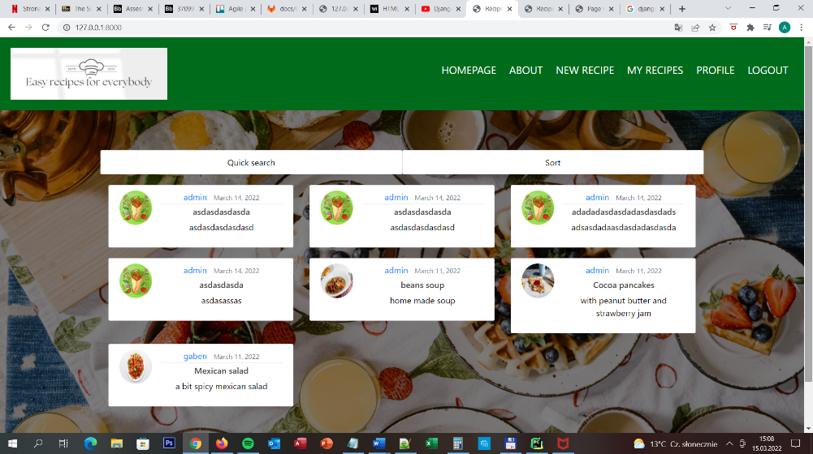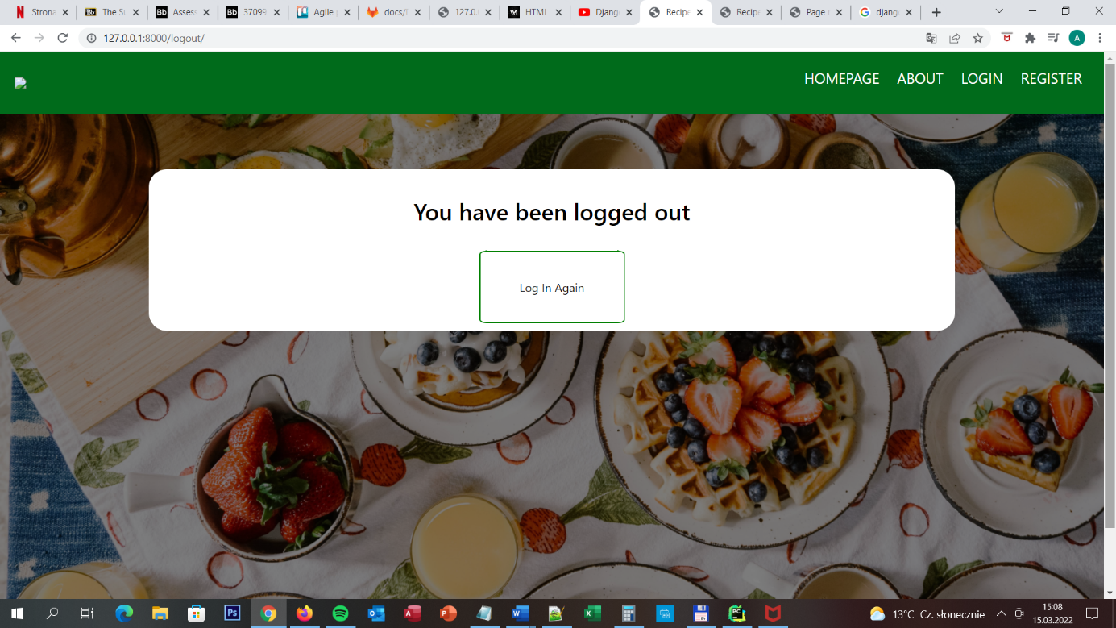

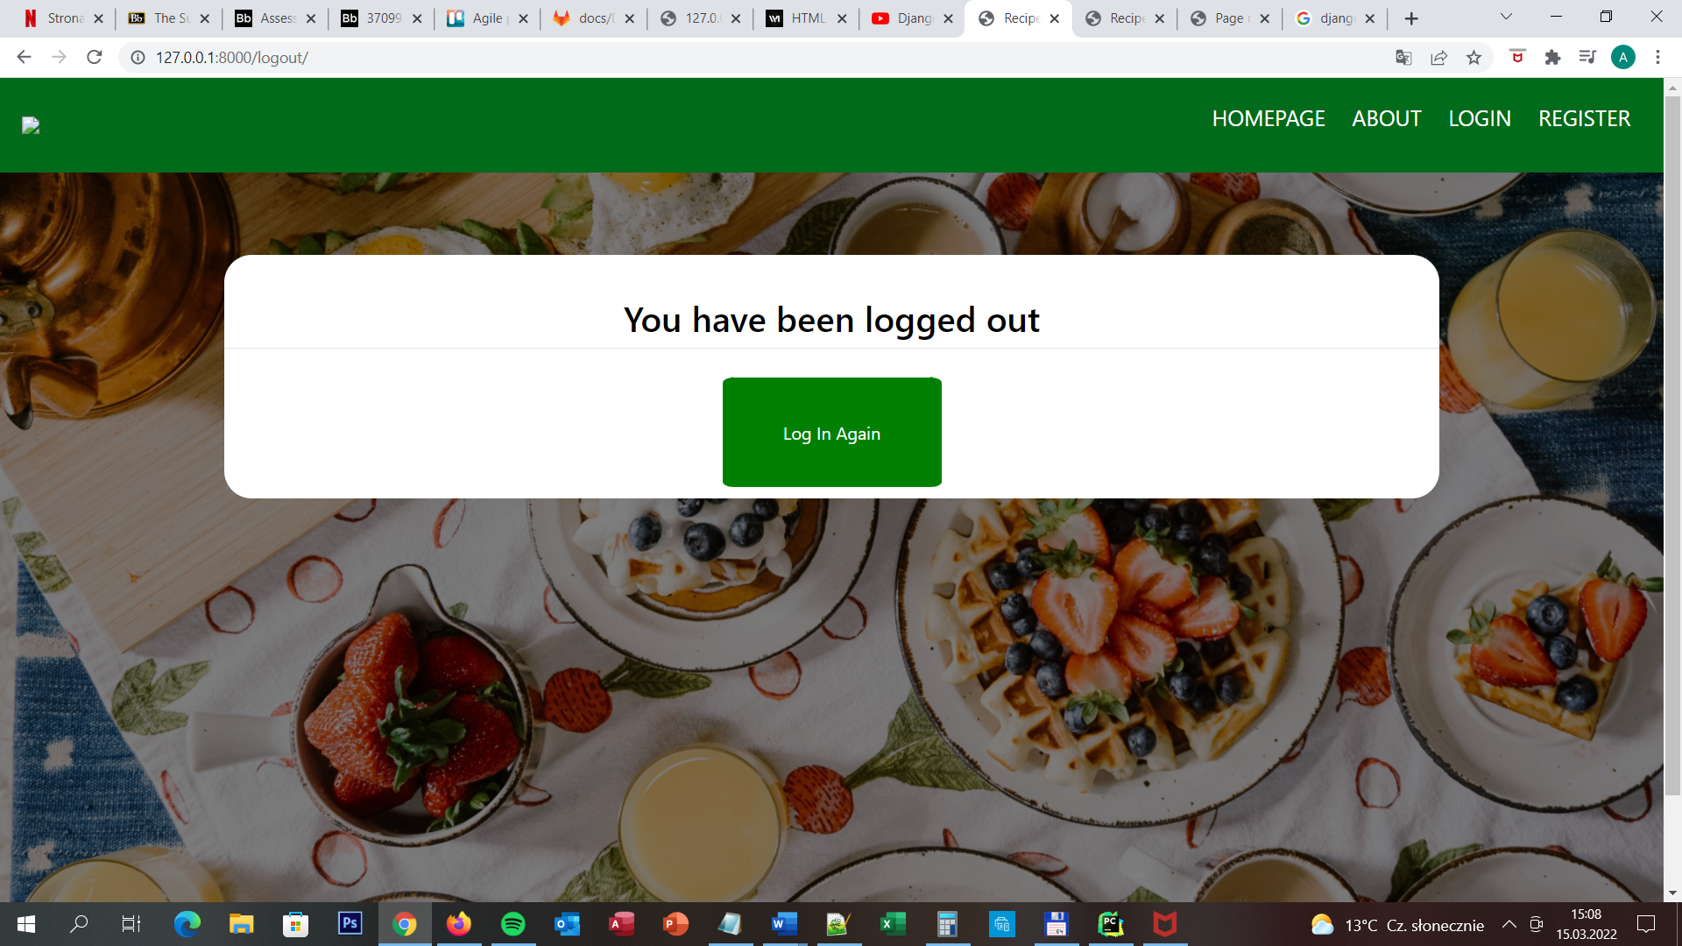

### Logout page

On the screen the ser is able to see message when he/she is successfully log out and button – Log In Again – to move user to the Login Page. The button is changing the colour when the user puts the pointer on the button. On the top of the screen is navigation menu which is able to move user to Homepage, About page, Login page and register page. When user is pointing the mouse on any of the button on the navigation menu than the button is underline.

### URL diagram

NO

YES

### User story

This page will be able to use only by users which have account already. The user after login to the website will be able to log out and move to Log out page any time. The button to move to this page is appear in the right corner, on navigation bar on the top of the screen. The button will be always there to make sure that user will always find it. The position for the button is really intuitive and clear.

When user clicks Log out button, he/she is automatically log out from the website. That means that he/she is no longer able to see the pages which he/she was able to see when he/she was log in to the website. When the process of Log out will end successfully the user is able to see the message on the screen – You are successfully log out from the website! – this is really important to inform user about it, to make good and clear connection on the line user-website.

If user want to come back to the main(first) page of the website, he/she is able to use button HOME which is located in top right corner on the top of the screen.

### Acceptance Criteria

When user is successfully log out from the website, on the screen is appear message - You are successfully log out from the website! – on the centre of the page.

After successfully log out from the website user is no longer able to see the pages which he/she is able to see after he/she is login to the website – for example profile page, favourite recipes page etc.

User can’t go back to previously page using back arrow on the web browser. If he/she clicks this button he/she should be automatically move to login page.

The button – HOME – in the right, top counter on the top of the website on navigation bar is moving user to main page.

### User interface – Pseudo code

The Log out page is appear for the user after he/she presses button LOG OUT which is located on the top of the screen, on the navigation bar in the right, top corner. The button is appear on all of the pages after user is successfully log in to the website on the same place.

The main part of the page is working on the background. On the user side is only press the button. The server side is closing all of the connections between user account and page and when it is finish successfully the server is printing on the screen message that user was successfully log out. Before the server will print the message, the server needs to close the user session to make sure that even if user will press back arrow on the web browser, he/she will not able to see any of the page which user was able to see after log in to the website. All of this is for security.

REFERENCES

[1] PostgreSQL Organisation, Datatypes, <https://www.postgresql.org/docs/9.5/datatype.html>

DOCUMENT HISTORY

| *Version* | *Date* | *Changes made to document* | *Changed by* |
| --- | --- | --- | --- |
| 0.0 | 20/02/22 | Initial creation of the document | SHW30 |
| 0.1 | 23/02/22 | Database tables and implementation design included and explained. | SHW30 |